PRECEPT Genesis II, Lesson 1

Lecture Notes from Dr. Kurt Wise

The Creation Foundation: Knowing Him More

God: Our Creator AND Sustainer

Genesis 1-2 | Genesis 3-11 | Genesis 12-Revelation | The Church
6 Days | 2,000 years | 2,000 years | 2,000 years

DANGER: Using science to prove that God is Creator as a result of an argument.

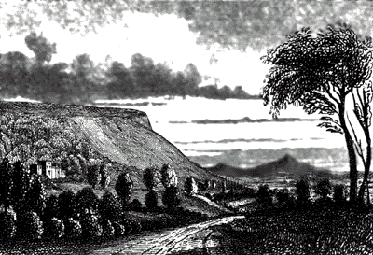
Romans 1:19-25
- because that which is known about God is evident within them; for God made it evident to them.

For since the creation of the world His invisible attributes, His eternal power and divine nature, have been clearly seen, being understood through what has been made, so that they are without excuse.

HOWEVER…..

For even though they knew God, they did not honor Him as God, or give thanks; but they became futile in their speculations, and their foolish heart was darkened.

Professing to be wise, they became fools

and exchanged the glory of the incorruptible God for an image in the form of corruptible man and of birds and four-footed animals and crawling creatures.

How Do We Come to Know that God Exists?

CONSCIENCE  Romans 2:13-15 | “THEI-SCIENCE”  Isaiah 6; Revelation 1
Available to believers and unbelievers | Available to believers and unbelievers
Speaks to our heart through  knowing that good & evil exists | Speaks to our heart through  “awe experiences”…WOW!
Just obey.  Conscience doesn’t give rational reasons. | There IS a Creator!  Opens a person’s heart to hear the gospel.
Obedience results in “peace” | Disobedience results in “fear”
“I am a sinner” | “I am accountable; I need a Savior.”

Ecclesiastes 12:1
Remember also your Creator in the days of your youth, before the evil days come and the years draw near when you will say, “I have no delight in them”;

